ULTv;\ULTWFZF o@)!# v!$GM VC[JF,
TFZLB ov kYD ;+DF\ kJ[X5F+ lJnFlY"GL AC[GMG[ VFJSFZ ;FY[ ULTv;\ULTWFZF :J~54lJEFJGF TYF k:T]TWFZFDF\ HM0FJF V\U[ klTEFJ T[DH JFlQ"S SFI"S|DM\ V\U[ RRF" ;EF4 DFU"NX"G SFI"S|DG]\ VFIMHG SZJFDF\ VFJ[,P VF SFI"S|DGF D]bI JSTF TZLS[ 0F"P V[DPV[GP JF3[,F ZC[,P
TFZLB o !v&v@)!# GF ZMH HF6LTF ,MSUFILSF TYF 8LPJLP S,FSFZ ,,LTF AC[G 3M0FN=F GF ,MSUFIG vJFNG SFI"S|DG]\ VFIMHG SZJFDF\ VFJ[,]\ T[DH ;F\HGF 5F\R S,FS[ SFjI;\wIFGM SFI"S|D ZFBJFDF\ VFJ[,P SlJ ;\D[,G NZlDIFG U]HZFTGF bIFTGFD SlJzLVM wJFZF SFjI5F9 TYF ULT4Uh,GL ;]\NZ ZH}VFT SZJFDF\ VFJ[,P
TFZLB o *v&v!#GF ZMH V\U|[HL DFwIDGL lJnFlY"GL S]DFZL GFYLAC[G DM-JF0LIF wJFZF AF/ULTM ZH} SZJFDF\ VFJ[,P
TFZLB o!%v&v!#GF ZMH 5MZA\NZGF lGJ'T VwIF5S VG[ HF6LTF ,MS S,FSFZ JH]EF. 5ZDFZ wJFZF N]CFvK\N4XMI"ULTM4,MSULTM GF UFIGvJFNG SFI"S|DG]\ VFIMHG SZJFDF\ VFJ[,P
TFZLB o @(v&v!#GF ZMH kFPZFS[X SSS0 wJFZF —DFGJ HLJGDF\ UFIGvJFNGG]\ DCtJ˜ jIFbIFG TYF AF/ULTM ZH} SZL T[GF lJX[ DFU"NX"G VF5JFDF\ VFJ[,P
TFZLB o %v*v!#GF ZMH ,MS;FlCtI TYF ,MSULT lJQI 5Z kFP;]CFlUGL UZFl;IF wJFZF ;\EFQ6G]\ VFIMHG SZJFDF\ VFJ[,]\P
TFZLB o#)v!)v!#GF ZMH IMU ;\:S'T I]lGJ;L"8L CZäFZ pTZF\R, YL p5l:YT 0F"PZFS[X JDF" TYF 0F"PVEI EFZäFH G]\ GFNIMU p5Z jIFbIFG ZFBJFDF\ VFJ[,P
TFZLB o!#v!v!$ GF ZMH I]PHLP;LP 0FID\0 HI]lA,LGL pHJ6LG[ VG],2L l0A[8G]\ VFIMHG SZJFDF\ VFJ[,P lJQI o —kFZaW A0F IF 5]~QFY" ˜
TFZLB o ^v!v!$ GF ZMH kFPJQF" HMQLG]\ J[ND\+ UFG 5Z jIFbIFG ZFBJFDF\ VFJ[,P

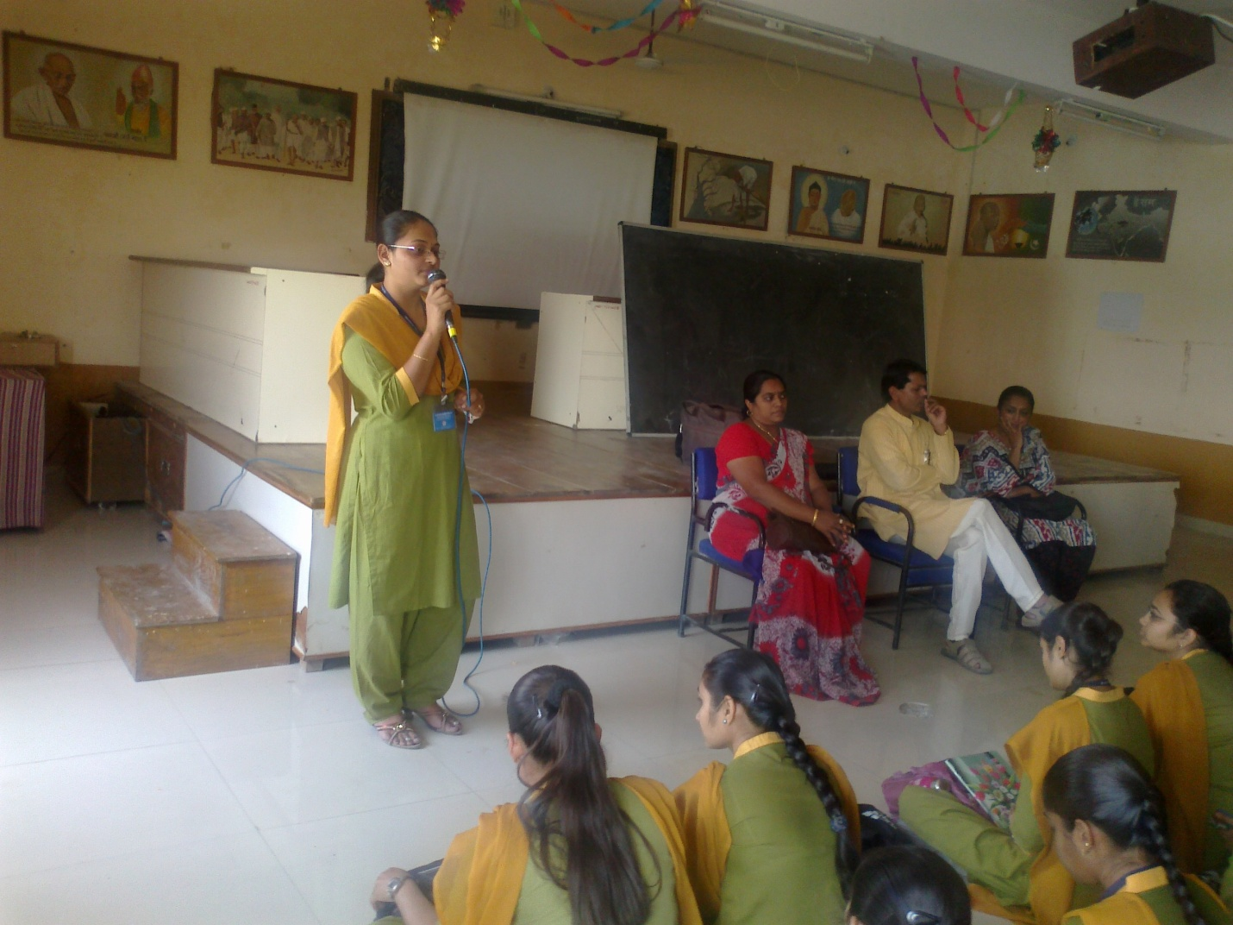
ULTv;\ULTWFZF SgJLGZ 0F"PV[DPV[GPJF3[,F4;eIzL 0F"P;\ULTFAC[G4kFP;]CFlUGLAC[G

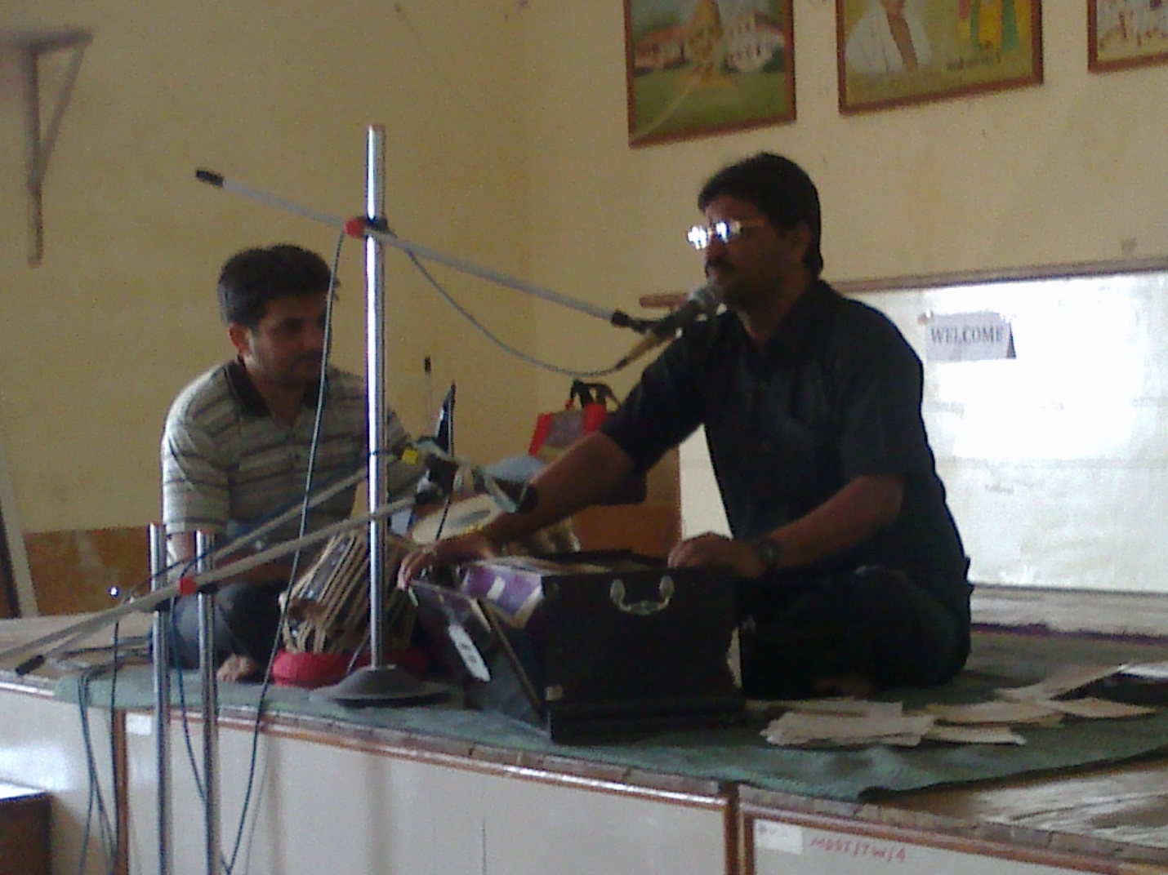
TFZLB o@#v(v!# GF ZMH HF6LTF ,MS;FlCtISFZ zL ElSTNFG U-JL wJFZF ,MSULTM TYF ElSTULTM GF SFI"S|DG]\ VFIMHG SZJFDF\ VFJ[,P

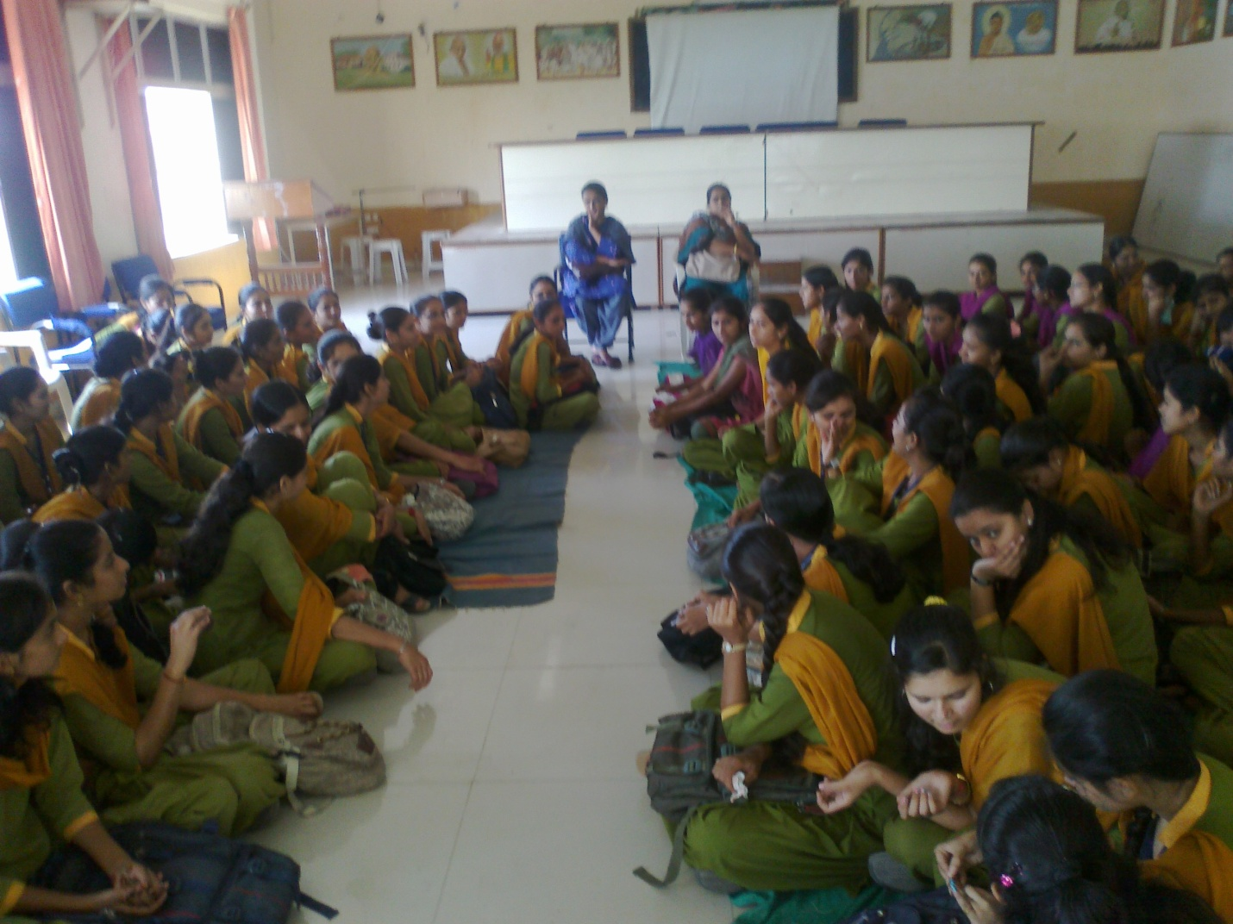
TFZLB o#)v(v!# GF ZMH V\TF2ZL SFI"S|DG]\ VFIMHG SZJFDF\ VFJ[,PlG6F"IS TZLS[ 0F"P;\ULTFAC[G TYF kFP;]CFlUGLAC[GP

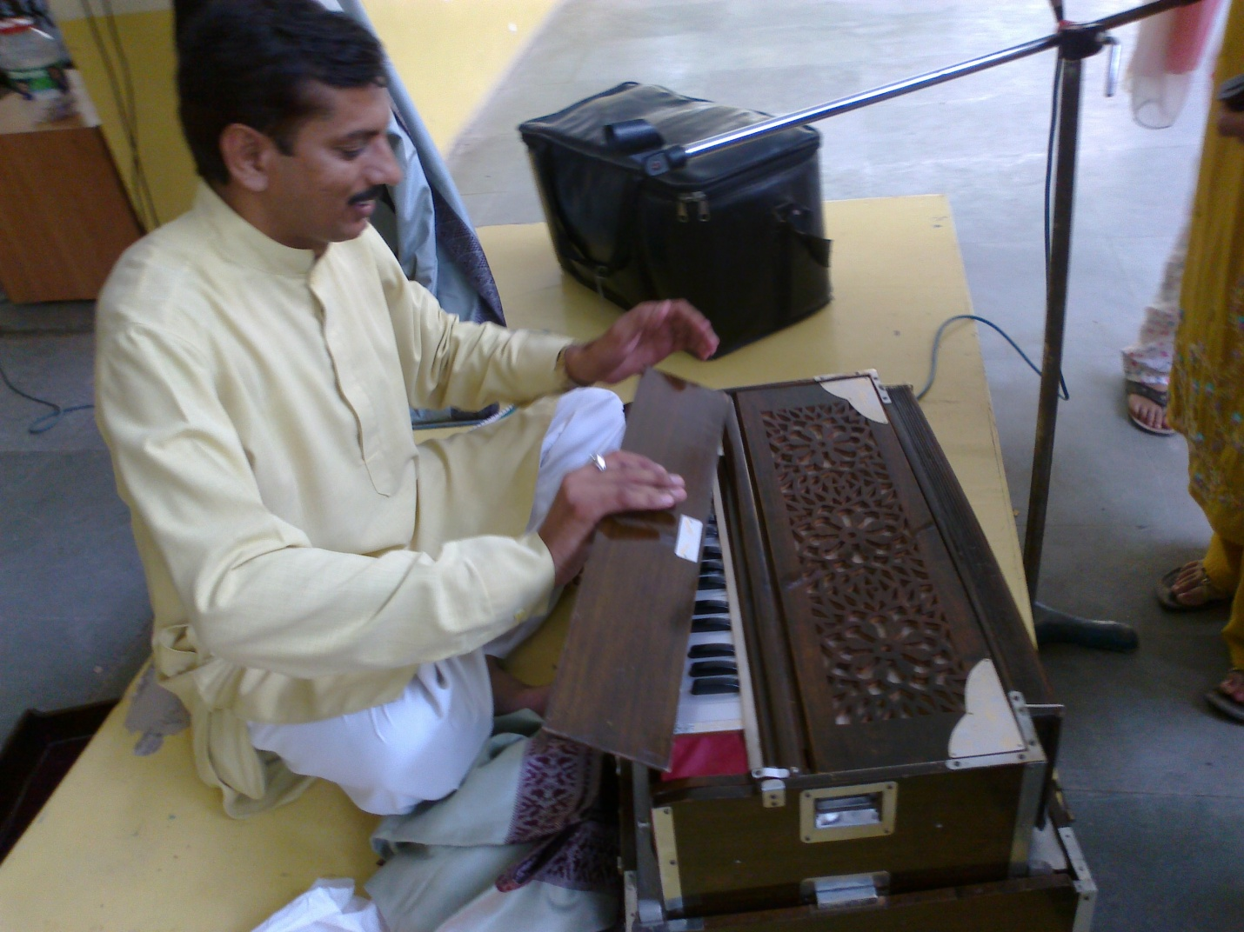

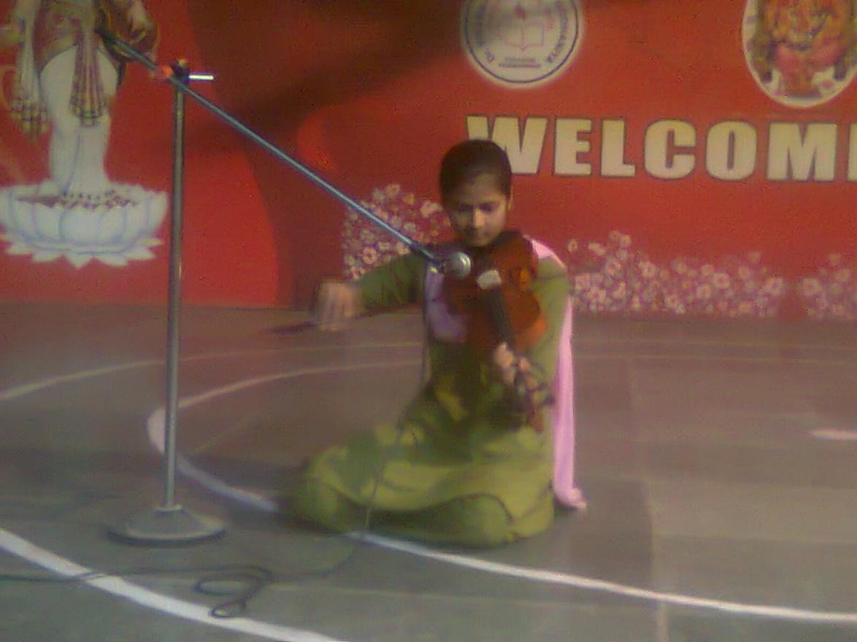
kFY"GF D\R 5ZYL JFIMl,G 5Z ULT ZH} SZTL lJnFlY"GL S]DFZL ,BWLZ
ULTFP
